USER’S MANUAL

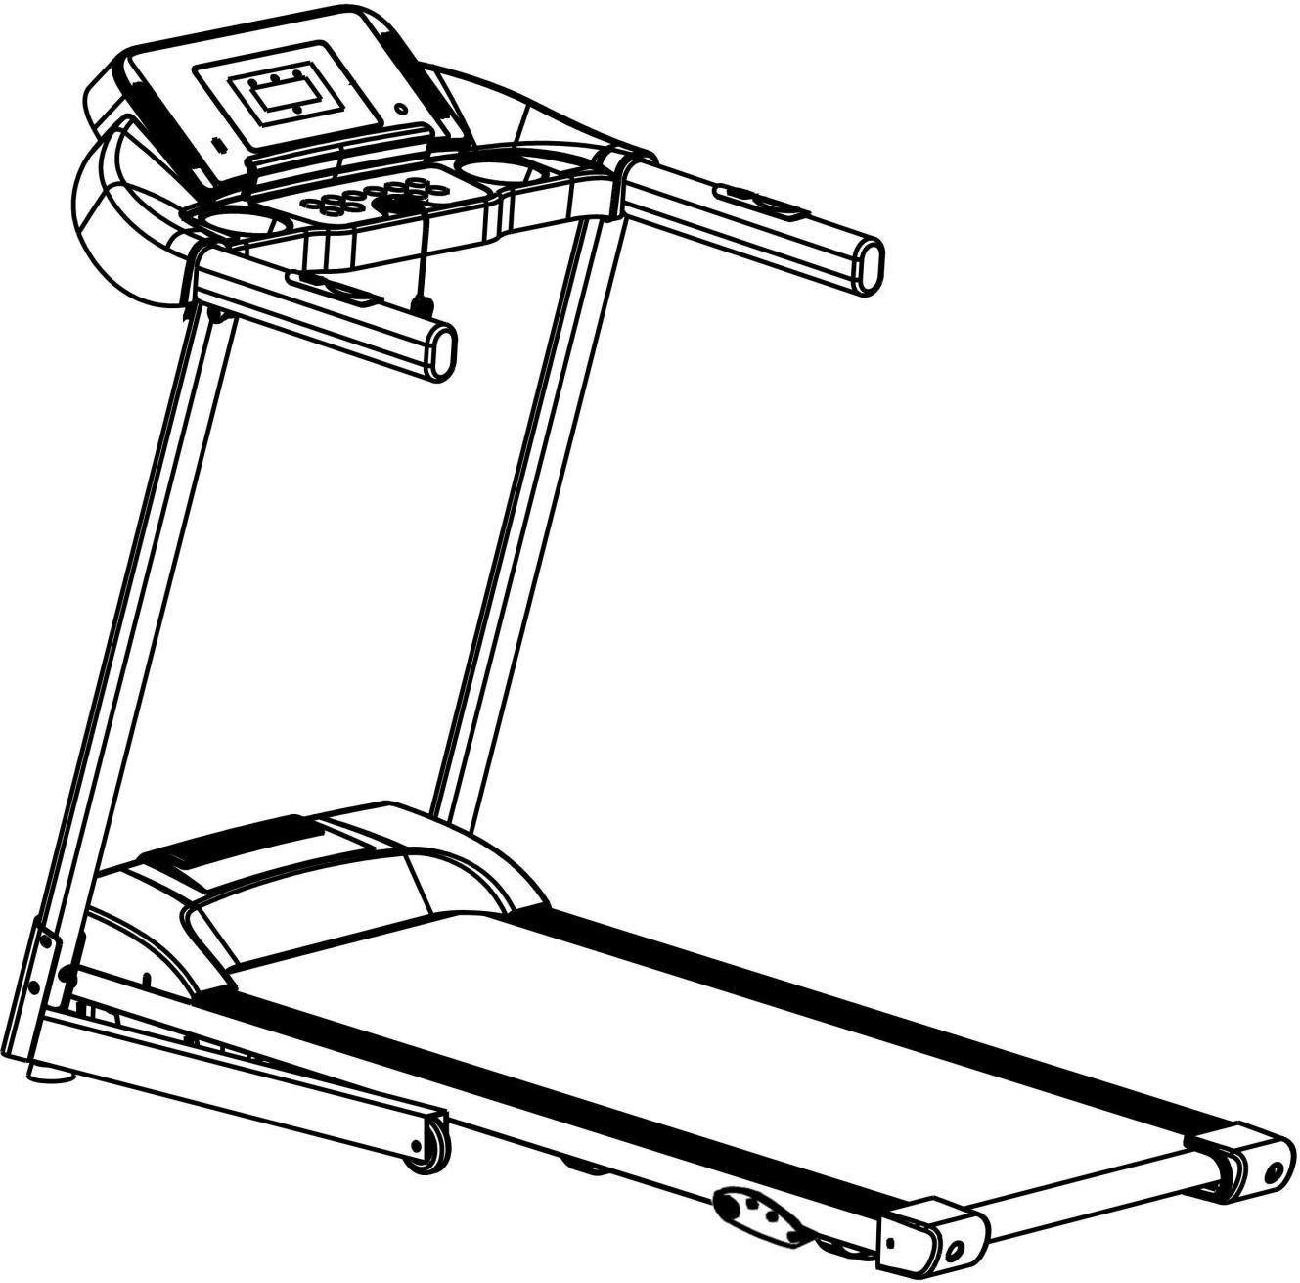

PLEASE DO NOT RETURN PRODUCT TO THE STORE.
If you have any problem or concerns, please feel free to contact our customer service department. Please send your request to the following contact details according to the platform you purchased.
Walmart Platform:
E-Mail: wmcsr@comptree.net
Tel: 626-912-8886 Ext.100
Other(Amazon, Wayfair, Homedepot, Overstock etc.) Platform:
E-Mail: csr@merax.com
Tel: 626-912-8886 Ext.100

Contents
- Product Brief 1
- Security Precautions and Warning 2
- Installation Instructions 5
- Using Instructions 8
- Routine Maintenance and Instructions 12

Product Brief

Product name: Single function Motorized Treadmill

Console

Upright column

Motor cover

Side rail Running belt End caps
Main parameters and parts list
No. | Parameters Names | Description
1 | Input power voltage | 110V～
2 | Rated frequency | 50-60Hz
3 | Rated power | 2.0HP
4 | Speed | 0.8-16km/h
5 | Running surface | 15.8*45.3inch
6 | Max user weight | 220LBS
7 | Expand dimensions | 54*27*43 inch
Packing list
No. | Name | Units | Qty |  | No. | Name | Units | Qty
1 | Complete machine | pc | 1 |  | 2 | Accessory Bag | pc | 1
Accessory Bag list
No. | Name | Units | Qty |  | No. | Name | Units | Qty
1 | Inner hexagon wrench 6mm | pc | 1 |  | 6 | Screws M8*25 | pc | 2
2 | Inner hexagon wrench 5mm | pc | 1 |  | 7 | Safety Key | pc | 1
3 | Mp3 Cable | pc | 1 |  | 8 | Silicon oil | pc | 1
4 | Screws M8*22 | pc | 4 |  | 9 | User manual | pc | 1
5 | Screws M8*45 | pc | 2

Notice:
  - Security Precautions and Warnings
Tip: Before folding the treadmill, make sure that the surface incline is "zero".

Please read the instructions carefully before use.

This treadmill is for indoor use and storage only. Avoid spilling water on it or placing it in damp areas.
Please wear suitable workout clothes and sneakers before exercise. Do not exercise on the treadmill barefoot.
The attached high power plug cord must be touching the ground when plugged in. Treadmill cord should be plugged into one dedicated electric outlet/circuit, do not share the electric plug outlet you are using for your treadmill with other electrical equipment.
Keep children away from the machine to avoid accidents.
Avoid using the machine for uninterrupted long periods of time, as this will overload the operation and cause damage to the motor and controller, and will accelerate the deterioration of the bearing, running belt and running board.The treadmill should be maintained regularly per the instructions listed throughout the manual.
Keep machine away from areas with high levels of dust to avoid strong static. Please turn off the treadmill by switching off the electric power after using.
Please ensure you are running in a well ventilated area.
Please clamp the security lock cable on your clothing to make sure the machine stops in the event of any emergency situation.
If you do not feel well while using this machine, please stop and consult a doctor. The included silicone lubrication must be kept away from children after use.
If the power cord is damaged, please contact our qualified maintenance personnel for service rather than disassemble it at csr@merax.com.

Forbidden
!

Don't use the machine if the outer protective shell is broken or has broken off, leaving any part of the internal structure exposed, or if the welding parts have fallen off or appear as if they may fall off.

---- Otherwise an accident or injury may occur.
Don't jump up and down while the treadmill is in motion.
---- Injuries may result from falling.
Don't keep machine in or near moist/damp space such as thebathroom.
- Don’t place machine in direct sunlight, or high temperature places such as near a stove ora heating appliance.
----Otherwise it may cause leakage and burst into flames.
Don't use if the power cord is damaged or the power plug pin is loose.
----Otherwise this will lead to an electric shock, short circuit or fire.
- Don't damage, forcefully bend or twist the power cord. Don’t place heavy objects on the machine, don't clamp the power cord.
----Otherwise it will cause a fire or you can get an electric shock.
Do not allow more than 1 person use the machine at one time, do not allow others to get close to the machine while it is in use.
---- Or it may cause an accident or injury due to possible falls.
- People who aren’t in a normal conscious state or can’t operate the machine bythemselves cannot use the treadmill.
----May lead to accident or injury.
Drinking water or pouring water when treadmill is in use/operating is forbidden.
---- May cause electric shock or fire.
People who seldom exercise are advised not to suddenly use the treadmill for any intensive workout.
Do not use machine, directly after a meal or when feeling tired.
---- This may lead to potential health damage or accidental injury.
This product is suitable for residential use. This product is not recommended for commercial use, schools, gymnasiums, etc
---- When used for commercial purposes there is a risk of injury.
- Don’t use the treadmill when hard objects are in the pockets of your pants or shorts.Remove them before using the machine.
----Not removing hard objects from your pockets before use may cause accident or injury.

- Don’t use the treadmill when the power plug is on or near the needle, garbage, or water.
----May cause electric shock, short circuit, or fire. Do not touch the power plug with wet hands! When not in use, pull out the power plug from the socket.
----Surrounding dust and moisture can age the insulation, and result in a possible leakage fire. This appliance is not intended for use by persons (including children) with reduced physical, sensory or mental capabilities, or lack of experience and knowledge concerning treadmills, unless they are being supervised or have been given instructions concerning use of the appliance by a person responsible for their safety.
Children should be supervised during use to ensure that they do not play with the appliance and or use it in ways it was not intended for.

Treadmill Grounding Safeguard System
!
This product must remain on the ground while in use at all times. If you notice the machine seems to be dysfunctional or unstable, keeping the treadmill on the ground will allow electricity to flow directly into the ground reducing the risk of electric shock.
This product is equipped with power plug that has a grounding conductor that can auto connect the treadmill electricity into the ground. Completely insert the plug into a standard socket for proper use.
- If the treadmill’s grounding conductor’s connection is improper, it will cause electric shock. If you have any doubt about whether your product is grounded correctly or not, please contact a professional to check and verify for you.
When plugging in the treadmill power cord, please plug it into a socket that has the same shape as the plug itself. Do not use a plug adapter.

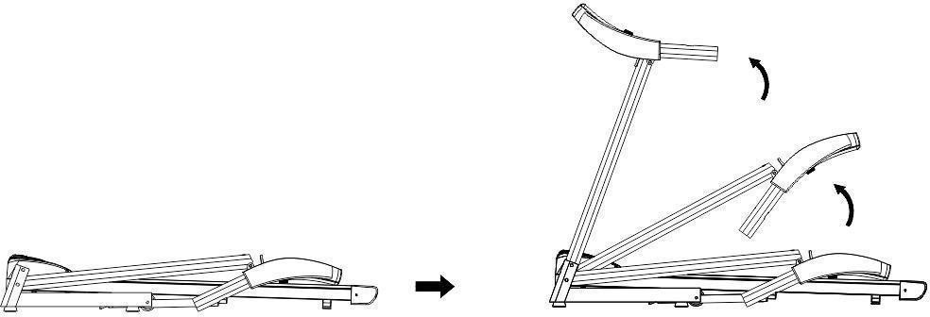
Installation Instructions
When installing, simple arrange all of the screws in their proper position first, then tighten the screws the treadmill frame has been positioned when the installation of frame is done.
NO. | Name | QTY
1 | Complete Machine | 1PC | 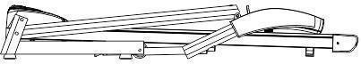
2 | 6mm inner hexagon wrench | 1PC | 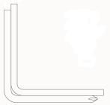
3 | 5mm inner hexagon wrench | 1PC
4 | Safety key | 1PC | 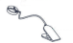
5 | Silicon oil | 1PC | 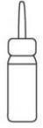
6 | MP3 cable | 1PC | 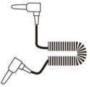
7 | Screw M8*22 | 4PCS | 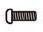
8 | Screw M8*25 | 2PCS | 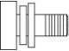
9 | Screw M8*45 | 2PCS
10 | User’s manual | 1PC

- Place the machine flat on the ground. Raise the supportive columns and console upward in the direction shown by the arrows in the picture below.

- Use 5# hexagon wrench to secure the upright columns on the base with screw M8*45 and nuts(A, one on each side). And then secure it with screw M8*22(B, two on eachside).
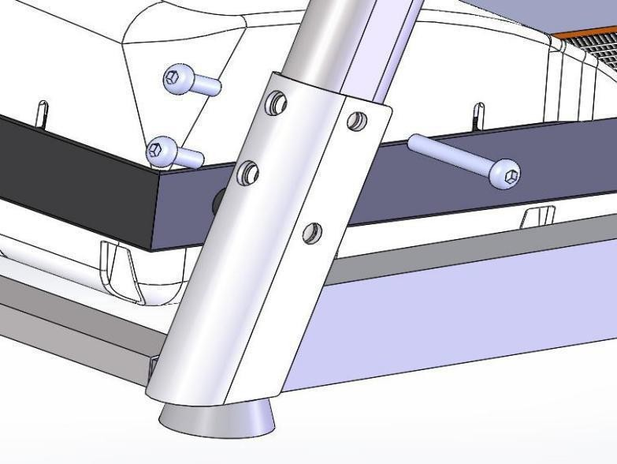
B
A
M8*22
M8*45
- Hold the left and right columns upright, then using 6# hexagon wrench to secure the console frame to the upright columns with screw M8*25.
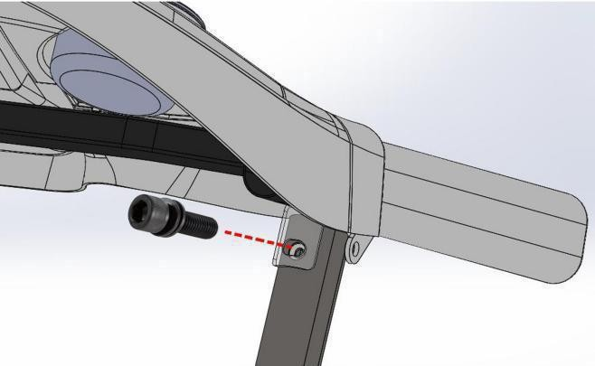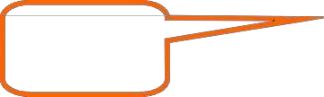
M8*25
- Put the safety key on the yellow circle on the console, as seen in the picture below. Press the start button to start the treadmill.

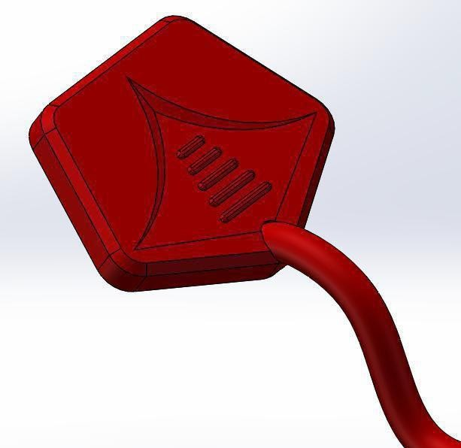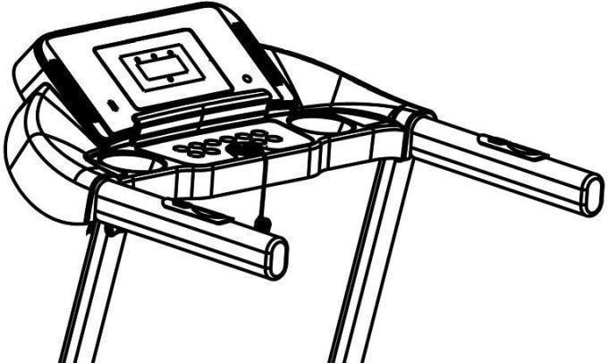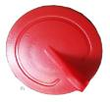

* According to the personal demands, three levels of manual incline for choose as below:
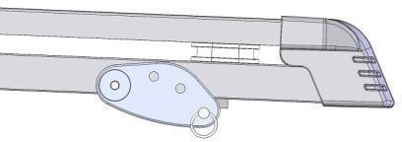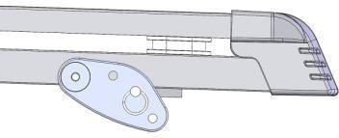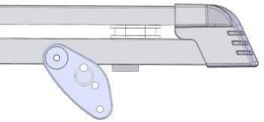
Level 1 Level 2 Level 3

NOTE: after you have finished putting the treadmill together, ensure that all screws are installed in their appropriate place according to the previous steps. Please ensure all parts are properly locked in and secured by screws before plugging in electricity.

Using treadmill

4.Using Instructions

- Insert the power plug properly and turn on the switch(in red color)
When the light is on, you will hear beep sound, and then the screen will light up.
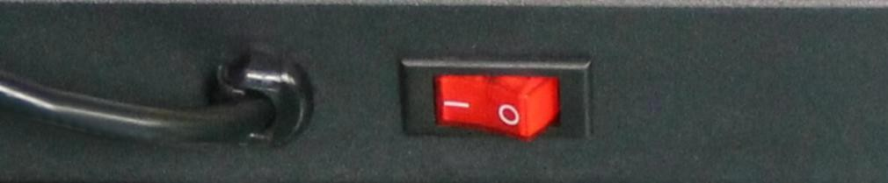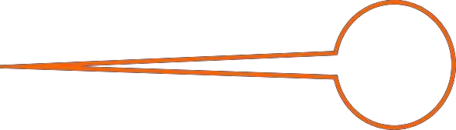
1
- Safety key Introduction
The treadmill can only start when the safety key is put on the yellow area of the display console. Clip the safety key on clothes when using the treadmill to avoid accidents. For emergency conditions, remove the safety key can stop the treadmill immediately. And put the safety key back to continue using the treadmill.

- Folding Instructions Fold the treadmill:
It saves space when the treadmill is folded.
Please turn off the switch and pull the power plug out before folding. Lift the running deck until it is held.
Unfold the treadmill:
Kick the pressure rod, and let the running deck lower down gradually.
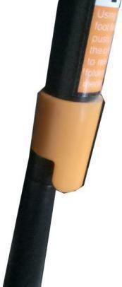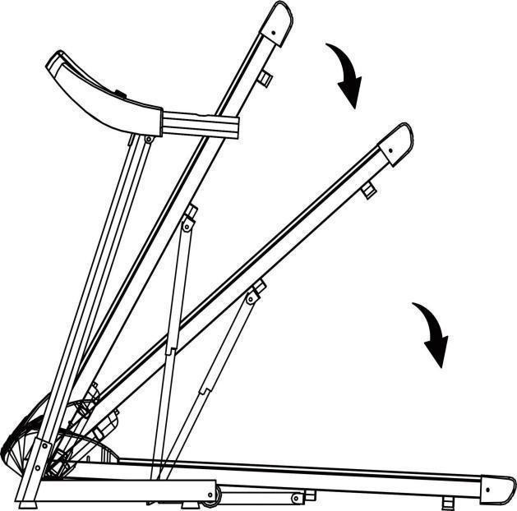
Kick here to
lower the running deck.

- Console instructions
Start-up: Press Start button to start the treadmill. Normally start after 5 seconds of the countdown.
Programs and modes: There are 12 automatic programs and 3 modes.
Safety lock function: When the safety key is disconnected, “E7” will appear on the screen, the treadmill will gradually stop and you will hear a beeping sound. When you put the safety key back, all of the data on the screen will be cleared in 2 seconds. Under whatever circumstance, the treadmill will stop when disconnected from the safety key and it will immediately show the data from your run on the screen. Once you put the safety key back, the data on the screen willreset.

- Button function

Startbutton/Stop
When the power is on, press the start button and the screen will display “0.8 km/h”, and the treadmill will start. When you are running on the treadmill and press the stop button, all of thedata on the screen will clear and the treadmill will gradually come to a complete stop and return to manual mode. Quick buttons located on the handle grip can also be used to start or stop the treadmill(left side) 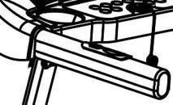

Program
When the treadmill is in standby mode, pressing the program key multiple times can cycle the options from manual mode to different automatic programs (P1-P12). The default speed while using manual mode is 0.8 km/hour, the highest speed is 16.0km/hour.

Mode
When the treadmill is in standby mode, press the mode key to cycle through 3 different ways to countdown your running: time, distance and calories.

Speed quickbutton 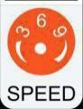
Press this button to directly adjust the speed into 3km/h, 6km/h or 9km/h in running state.

Speed ± button
Press these buttons to change the speed in running state. Speed quick buttons on the handle gripcan also be used to change the speed of the treadmill(rightside). 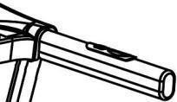

Volume ± button
Press these buttons to adjust the volume when playing music files in the pen drive or using the MP3 cable to connect to the phone to play music.

Play/Pausebutton
When playing music, press this button to pause the music and press it again to continue playing.

- Display Function

Speed Display
Display the current running speed value.

Time Display
Display the time of manual mode and the countdown time under automatic modes and programs.

Distance display
Display cumulative distance under manual mode and programs. Display the distance countdown in automatic mode.

Calorie display
Display cumulative calorie under manual mode and programs. Display the calorie countdown in automatic mode.

Heart rate display
The heart rate value will show on the display when you place your hands on the heart rate monitors. (The number is for reference only, it cannot be considered as medical data.)

7. Automatic program
Each program is divided into 10 segments, and the running time of each segment of the program is evenly distributed. Following is a form of speed distribution of 12 programs.

Time  Program |  | Set time/ 10 = Running time of each segment
 |  | 1 | 2 | 3 | 4 | 5 | 6 | 7 | 8 | 9 | 10
P1 | Speed | 3 | 3 | 6 | 5 | 5 | 4 | 4 | 4 | 4 | 3
P2 | Speed | 3 | 3 | 4 | 4 | 5 | 5 | 5 | 6 | 6 | 4
P3 | Speed | 2 | 4 | 6 | 4 | 3 | 4 | 6 | 2 | 3 | 2
P4 | Speed | 3 | 3 | 5 | 6 | 3 | 6 | 5 | 4 | 3 | 3
P5 | Speed | 3 | 6 | 6 | 6 | 4 | 3 | 3 | 5 | 5 | 4
P6 | Speed | 2 | 6 | 5 | 4 | 4 | 3 | 5 | 3 | 3 | 2
P7 | Speed | 2 | 5 | 5 | 3 | 3 | 6 | 5 | 3 | 2 | 2
P8 | Speed | 2 | 4 | 4 | 4 | 5 | 6 | 4 | 4 | 6 | 2
P9 | Speed | 2 | 4 | 5 | 5 | 6 | 5 | 6 | 3 | 3 | 2

P10 | Speed | 2 | 5 | 3 | 5 | 4 | 6 | 5 | 2 | 4 | 3
P11 | Speed | 2 | 5 | 6 | 3 | 4 | 5 | 6 | 5 | 3 | 2
P12 | Speed | 2 | 3 | 5 | 6 | 4 | 6 | 5 | 6 | 5 | 3

Error Code Meaning

Error code | Error Description | Error handling
E1 | Disrupted Electronic Connection: When turned on, the connection between the lower controller and the console isabnormal. | Possible Causes: The electronic connection between the console and lower controller is blocked, check each wire that connects the console with the lower controller, make sure that each wire base is fully plugged in. Check the cable of the console and lower controller, replace it if it’sbroken.
E2 | No motor signal | Possible Causes: The motor cable might not be connected. Check the connection, connect the cable if disconnected. The motor might be damaged. Check to see if it has visible damage or a burnt smell. If yes, replace the motor.
E5 | Electric Current Overload Prevention: When the treadmill is running, the controller detects the electric current is over 6A(unit to measure electricity) for more than 3 seconds. | Possible Causes: *Overloading the treadmill machine system through prolonged use can lead to excessive electric current and the treadmill will stop for your safety. *A part might be stuck causing the motor to stop, adjust the treadmill and restart it. *The motor may need to be replaced, check if there is a liquid or burnt smell while the motor is running, if yes replace it. *The treadmill monitor may need to be replaced, check if it has a burnt smell, if yes replace the monitor. *The power supply voltage may need to be changed, check the power supply voltage if it does not match specifications adjust to the correct voltage and test the treadmill again.
E6 | Explosion Prevention: An abnormal voltage level or motor issue has caused the motor to not work properly | Possible Causes: The power supply voltage may be low Check if the power supply voltage is 50% lower than the normal voltage of 110V, if it is, adjust it back to 110V and test the treadmill again. *The controller may need to be replaced. Check if the controller has a burnt smell, if yes, replace the controller. *The motor cable or wire may need to be reconnected. Check if the motor cable and wire are connected, connect if one or both are not properly connected.
E7 | No safety key | Put the safety key back on the yellow circle on the console.

5. Routine Maintenance
Warning: Before cleaning or doing product maintenance, please ensure the treadmill power plug is pulled out of the electric socket.
Cleaning: Thoroughly cleaning your treadmill will extend its usage life.
Remove dust periodically in order to keep the parts clean. Be sure to clean both sides of running belt, this will reduce the accumulation of dust and dirt. Treadmill belts must be cleaned with a damp soapy cloth. Do not use a dripping wet cloth. Please be sure to not wet the electrical components of the treadmill including underneath the running belt to keep everything dry andfunctional.
Warning: Ensure that the power plug is disconnected before removing the motor cover. Clean the motor at least once a year.
Running belt specialized lubricant
This electric treadmill’s running board and running belt have already been lubricated in the manufacturing process. Friction between the running belt and running board heavily impacts how long your treadmill will last and its performance, therefore regular application of the lubricant is needed. Please check the board regularly to ensure it is properly lubricated. If the board’s surface is damaged, please contact our customer service center. We recommend applying the lubricant between the running belt and running board using the following schedule:

Light user (uses treadmill less than 3 hours a week): Apply lubrication once a month
Heavy user (uses treadmill more than 7 hours a week): Apply lubrication twice a month, at the beginning of the month and halfway through the month.

- For safety measures and to extend the life of your treadmill, it is recommended that if you use the treadmill for 2 hours or more non-stop, to turn off the machine and let it rest for 10 minutes before using again.
- If the treadmill belt is too loose, you will experience skidding while running. If the belt is too tight, it may reduce motor performance and increase friction between the roller and running belt impacting your running experience. You can lift two sides of the running belt for 50-75mm when the tightness is appropriate.
Running with adjusted alignment and tightness
In order to use your treadmill properly so it can function well, it is necessary for you to adjust the running belt into the best position.
How to align the running belt
  - Put the treadmill flat on the ground
  - Make the treadmill run at a speed of about 6-8km/hour
  - If the running belt is closer to the right, rotate the right adjusting bolt with a ½ turn clockwise, then rotate the left adjusting bolt with a ½ turn counter-clockwise (PictureB)
  - If the running belt is closer to the left, rotate the left adjusting bolt with a ½ turnclockwise, then rotate the right adjusting bolt with a ½ turn counter-clockwise (PictureA).

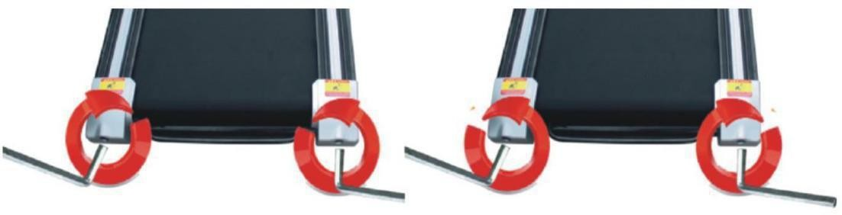

Picture A Picture B

Multi-wedge Belt Tension Adjusting
When you use the treadmill for a long time, the multi-wedge belt becomes loose because of the abrasion, then you have to do some appropriate adjustment to facilitate the safe use.
Judgment: the feeling of running with the occasional pause phenomenon, which indicating that the treadmill belt or multi-wedge belt are a little loose and further affirmation need to be made.
Method of judging which part is loose: Remove the four screws on protective cover, make the treadmill run at a speed of 1 km/h, and then stand on the running belt, grip the armrests, and tread the treadmill belt slightly.( we advise treading the treadmill belts with the user's ownweight)
- The instantaneous step can not stop the belt, the tightness is appropriate.
- If your instantaneous step stops the running belt, but the multi-wedge belt and front roller is still running, it indicates that the running belt is loose and appropriate adjustments must be made to facilitate the safe use.
- If you notice that the instantaneous step makes the treadmill belt and multi-wedge belt stop, but the motor is still running, it indicates that the multi-wedge belt is loose and appropriate adjustments must be made to facilitate the the safe use.
Step 2:Use a wrench to adjust the screws on the motor base according the the condition. Meanwhile, gently flip the multi-wedge belt between the motor shaft and the front roller, if it is too loose, you can flip the multi-wedge belt by 100%; if it is too tight, the degree for you to flip the belt is very limited. It is appropriate to flip the multi-wedge belt by 80% after adjustment. Please adjust the tightness of the multi-wedge belt into the state that it could be flipped by 80%.
Step 3: Finally secure the motor base, and install the motor cover.

Applying silicone oil
Step 1: Open up the treadmill belt
Step 2: Open the silicone oil bottle, squeeze the silicone oil to both sides of the running board, as in the picture bellow:
